GRAND 7” VISION TALK – MODEL 7
( Digital Media Player. Supports JPEG, MPEG Ⅰ/Ⅱ/Ⅳ, MP3 )

Model 7 – With Schedule Function

User’s Manual



ISSUE：2007/01/05
VERSION：UPD070106
P/N：34406006
CE
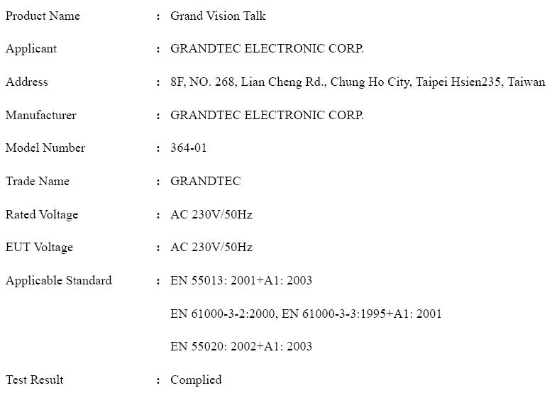

FCC
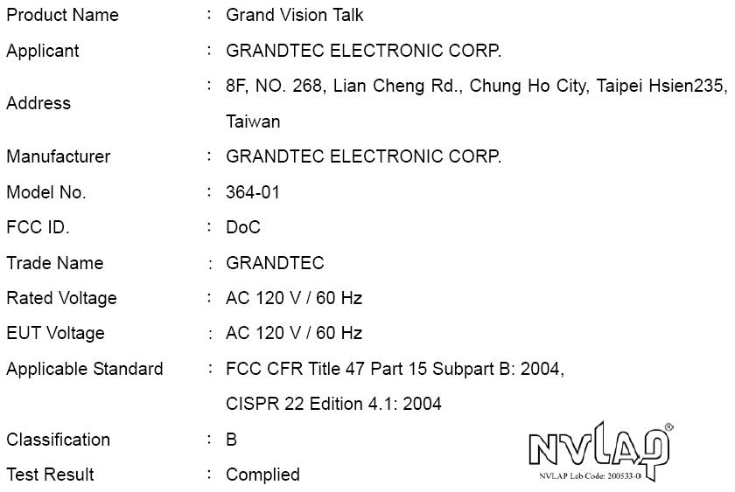

INDEX

1. Introduction……………………………………….……………………1
1.1 Introduction……………………….…………………………1
1.2 Package Contents…………………….……………………...1
2. Product Features………………………………………………………2
2.1 The Features of Schedule Software…………………………2
2.2 The Features of Grand 7” Vision Talk……………………...2
3. Hardware Connection and Reference…………………….………….3
3.1 Connectors of Grand 7” Vision Talk…………..………...3
3.2 Panel Buttons and Switch…………………….….……….3
3.3 Remote Controller Function Buttons…………..…………4
4. Grand 7” Vision Talk Setting Setup Reference…………..………...5
4.1 SLIDE SETUP……………………………………………...5
4.2 MUSIC SETUP…………………………..…………………5
4.3 MOVIE SETUP…………………………..………………..5
4.4 SLIDESHOW SETUP……………………………………..6
4.5 PREFERENCES……………………………………………..6
4.6 Timer Functions …………………….…..…………………...7
4.7 Photo Pan Function………………..….…….………..….….8
4.8 Photo Rotation………………………………………..……...8
5. Schedule Software Operation Reference……………………………...9
5.1 Install The Schedule Software………………………………9
5.2 Setup The Schedule Software……………………………….9
5.3 Apply The Schedule………………………………….……..14
6. Trouble Shooting……………………………….……………………15

1. Introduction
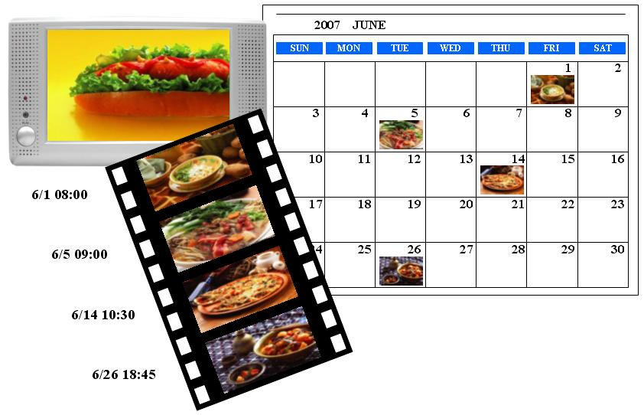

1.1 Introduction
Grand 7” Vision Talk with Schedule is an intelligent digital media player with 7” TFT panel that plays MPEG I/II/IV movies, MP3 music and digital pictures without a computer. The operation of the “schedule” software is very simple and easily, only select the files that you want to play and set up the initial and end time to play by your PC, and it will auto play the files at the designated time. With the portable Grand 7” Vision Talk, you can easily display the shows on 7” TFT LCD Monitor for Business, Education, Seminar, Presentation and Home Entertainment.

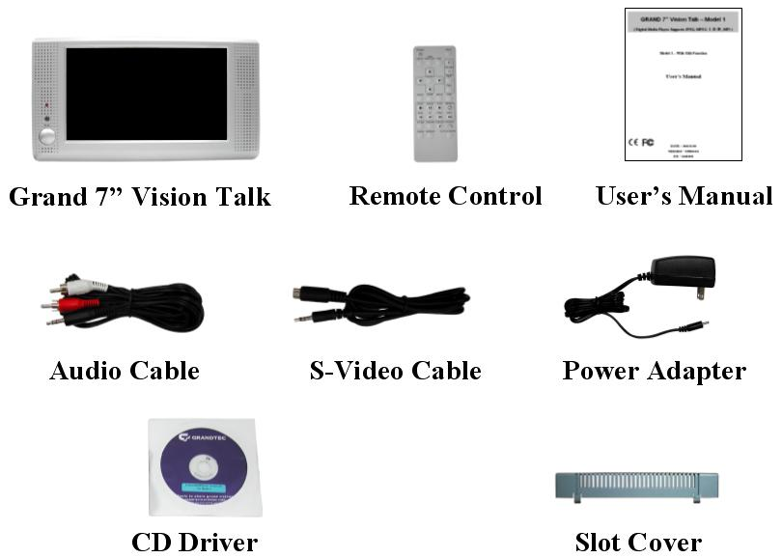
1.2 Package Contents
This package contains the following items:
- Grand 7” Vision Talk
- Infrared remote control
- User’s Manual
- Audio cable ( for audio input )
- S-Video cable ( for s-video input )
- Power adapter ( DC 12V )
- Slot cover ( in order to prevent the missing of memory card )

2. Product Features
2.1 The Features of Schedule Software
  - The operation of schedule software is very simple and easily.
  - The schedule software included “Basic Schedule” and “Advance Schedule” for set up, it can accord with your demand about various schedule.
  - The “Basic Schedule” supports up to 250 files (included MP3, JPEG, MJPEG(AVI) and MPEG Ⅰ/Ⅱ/Ⅳ) to broadcast.
  - The “Advance Schedule” supports up to 250 schedules, and each schedule supports up to 100 files (included MP3, JPEG, MJPEG(AVI) and MPEGⅠ/Ⅱ/Ⅳ) to broadcast.
  - The file name supports up to 16 characters, and the format supports figure, English letter, dash (-) and under line (_).
  - You can set up the volume, the repeated number of times that play, the initial and end time to play of each file.
  - After the setup of schedule is completed, you do not need control manually to play other files by yourself each time.
  - The Schedule software supports copy files function.

  - The Features of Grand 7” Vision Talk
  - Supports multiple file format：JPEG, MP3, MPEG Ⅰ/ Ⅱ/ Ⅳ.
  - Pure hardware design , just Plug & Display.
  - Supports CF Type I/II, IBM Micro drive MD, SM, MMC, SD, Memory Stick and Memory Stick PRO.
  - Supports Video, S-Video and Audio output.
  - Multi-Language OSD：English, French, German, Italian, Portuguese, Spanish, Netherlands, Japanese, Chinese.
  - Supports SLIDE SHOW (14 kinds EFFECT): with sequential and random.
  - Supports SLIDE TIME (INTERVAL) mode: interval time with 1,3, 5,10,30, 60 seconds and manual selection.
  - Supports MUSIC SLIDE show: MP3 with JPEG pictures play at the same time.
  - Supports ZOOM IN (ON) 4x & PAN, ROTATE, MIRROR, PREVIEW, REPEAT.
  - Includes Full functions Infrared remote Control.

3. Hardware Connection and Reference
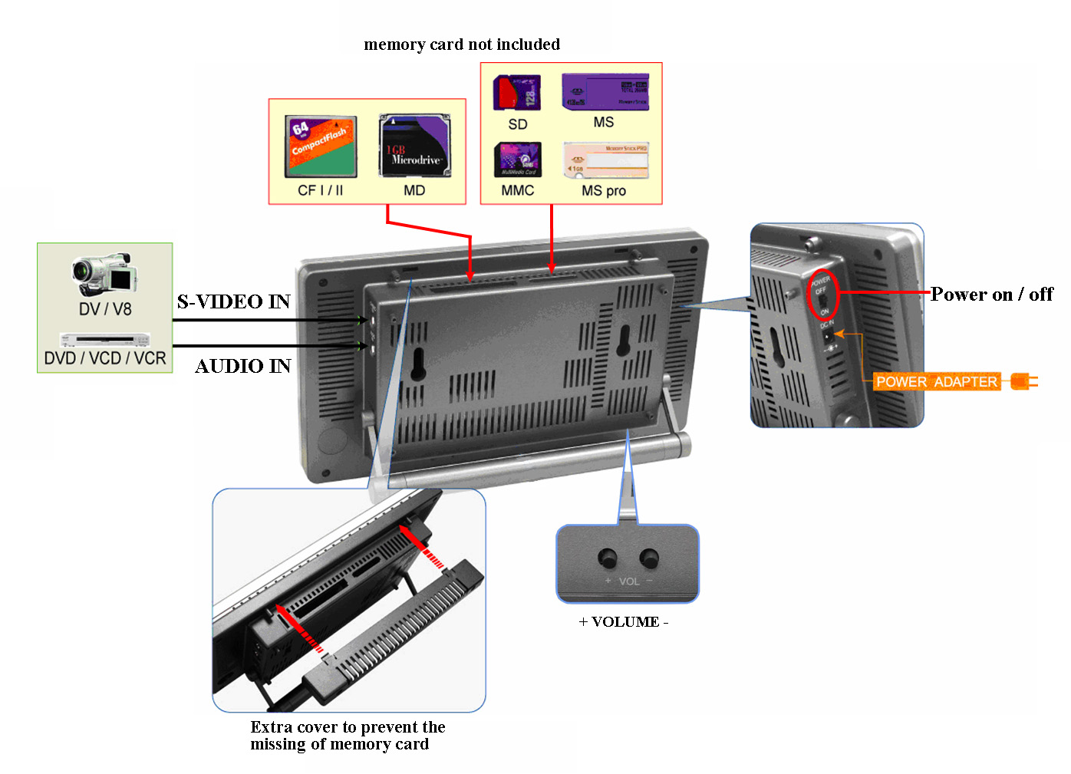

3.1 Connectors of Grand 7” Vision Talk
- DC IN: Plug with power cable.
- S-VIDEO IN: Supports S-Video input.
- AUDIO IN: Supports stereo audio signal input.
- SD/MS/MS PRO/MMC sockets: Insert cards into the sockets and supports SD, MS, MS PRO and MMC cards.
- Compact Flash I/II sockets: Insert cards into the sockets and supports CF I/II and MD cards.

3.2 Panel Buttons and Switch
- POWER ON / OFF: Toggle between power on & off.
- + VOLUME -：Volume up、down.

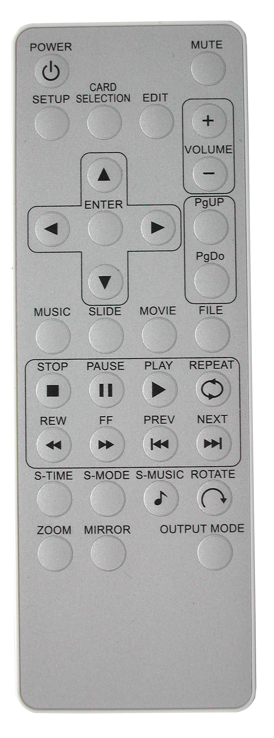
3.3 Remote Controller Function Button
- POWER：Toggle between power on & off.
- MUTE：Mute the Audio output.
- SETUP：Press this button to setup settings.
- CARD SELECTION：Choose a different memory card.
- EDIT：Timer Setup.
- + 、 — (VOLUME)：Volume up、down.
- 、 ：Move up or down when selecting on your TV screen.
- 、 ：Move left or right when selecting on your TV screen.
- ENTER：Confirm selections on your TV screen.
- PgUP：Go to the previous page or image.
- PgDo：Go to the next page or image.
- MUSIC：Go to and display all music files.
- SLIDE：Go to and display all photo files.
- MOVIE：Go to and display all movie files.
- FILE：Go to file library (all files).
- STOP：Stop the selected file or playback.
- PAUSE：Pause the playback.
- PLAY：Play the selected file.
- REPEAT：Play file repeatedly until stopped.
- REW：Rewind movies.
- FF：Forward movies.
- PREV：Go to previous file.
- NEXT：Go to next file.
- S-TIME：Slide show time adjustment 1, 3, 5, 10, 30, 60 seconds.
- S-MUSIC：The music slide show function allows you to play MP3 audio files while a picture slide show is being displayed.
- ROTATE：Rotate photo 90 degrees clockwise on screen.
- ZOOM：zoom in (on) the image up to 4x.
- MIRROR：When viewing images, you can use this button to mirror the image horizontally.
- Output Mode：Select the video output mode (Internal signal output / S-Video input).

4. Grand 7” Vision Talk Setting Setup Reference
- Press the “SETUP” button of remote control to open the “SETUP MENU – MAIN PAGE” like the figure as following. There are five groups of sub-menu in the setup menu.
- Press the “▲、▼、▲、▼” button to select item or adjust values, and press the “ENTER” button to into the function or confirm the command.

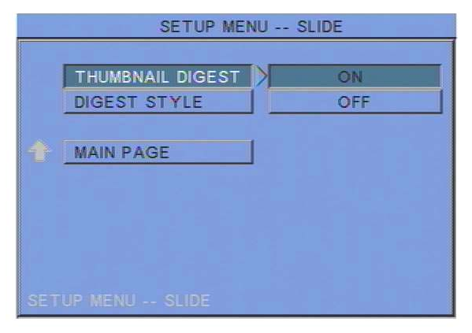
4.1 SLIDE SETUP: This screen lets you change the following settings.
- THUMBNAIL DIGEST：These thumbnails load faster and allow you to browse photos more easily .
- DIGEST STYLE：Choose the slide preview mode. (2x2 / 3x3)

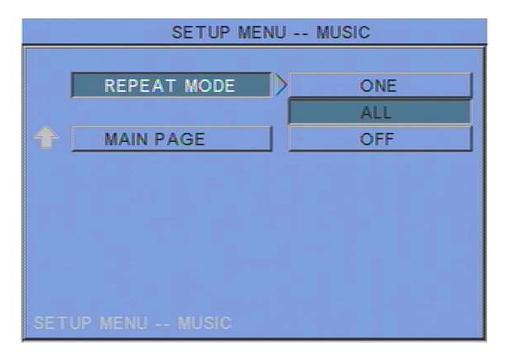
4.2 MUSIC SETUP: This screen lets you change the following settings.
- REPEAT MODE
• ONE：Repeats the selected song.
• ALL：Repeats all the songs on the memory card.
• OFF：Do not repeat any song.

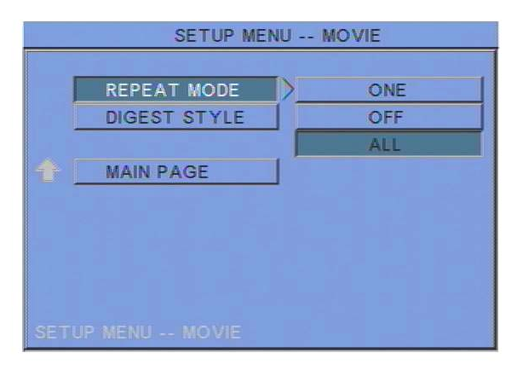
4.3 MOVIE SETUP: This screen lets you change the following settings.
- REPEAT MODE
• ONE：Plays the selected movie continuously.
• OFF：REPEAT MODE is turned off.
• ALL：Plays all movies on the memory card continuously (loop).
- DIGEST STYLE：Choose the movie preview mode.

4.4 SLIDESHOW SETUP: This screen lets you change the following settings.
- SLIDESHOW MODE：Set the slideshow starts automatically or not.
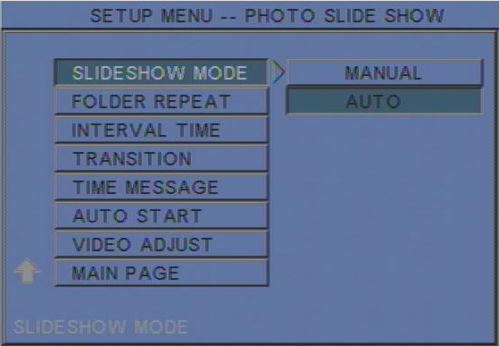
- FOLDER REPEAT：Set all files(pictures, mp3 or movies) in the folder are shown once or continuously (loop).
- INTERVAL TIME：Set the time each photo is shown. 1, 3, 5, 10, 30, 60 seconds.
- TRANSITION (EFFECT)：Set the transition mode between slides, and with sequential, random auto slide shows etc 14 kind of selections.
- TIME MESSAGE：Set the time message is shown on the screen constantly or not.
- AUTO START：When turned on, any media on the memory card plays automatically when the card is inserted.
- VIDEO ADJUST：To adjust the Brightness and Color of TFT panel. Please use 、 buttons to select the “BRIGHTNESS” and “COLOR”, and use 、 buttons to adjust.
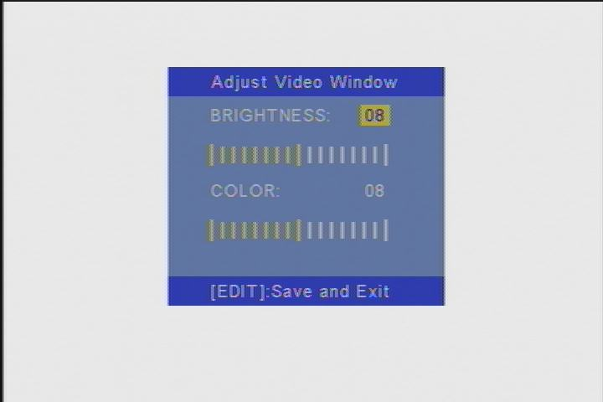
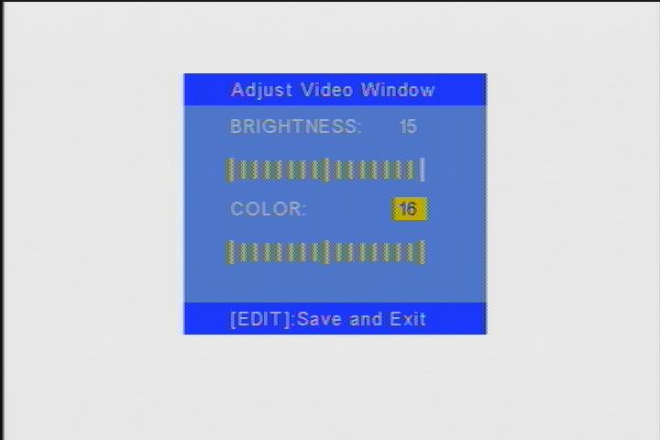

4.5 PREFERENCES：This screen lets you change the following settings.
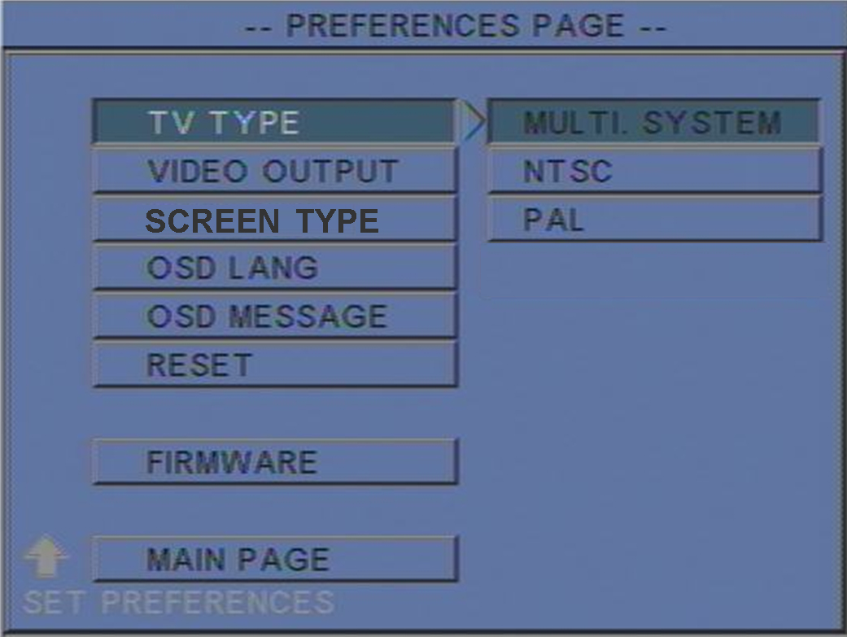
- TV TYPE: Choose the TV TYPE.
• MULTI . SYSTEM：Set the TV type automatically.
• NTSC: Set the TV type to NTSC.
• PAL: Set the TV type to PAL.
- VIDEO OUTPUT：Select the video output mode.
- SCREEN TYPE：Set the screen type to 16：9 or 4：3.
- OSD LANG: Choose the language for the OSD: ENGLISH, FRENCH, GERMAN, ITALIAN, JAPANESE, PORTUGUESE, SPANISH and NEDERLANDS.
- OSD MESSAGE: Set the OSD message on/off.
- RESET: Reset all settings to the original (factory) settings.
- FIRMWARE : New F/W can upgraded from Memory Card.
• EDITION : To show the F/W versions of Grand 7” Vision Talk.
• SC EDITION：To show the F/W versions of Schedule software.
• UPDATE : Selected to “ UPDATE “, F/W will be upgraded.
4.6 Timer Function
NOTE：Make sure the insulating slice has already been taken out.
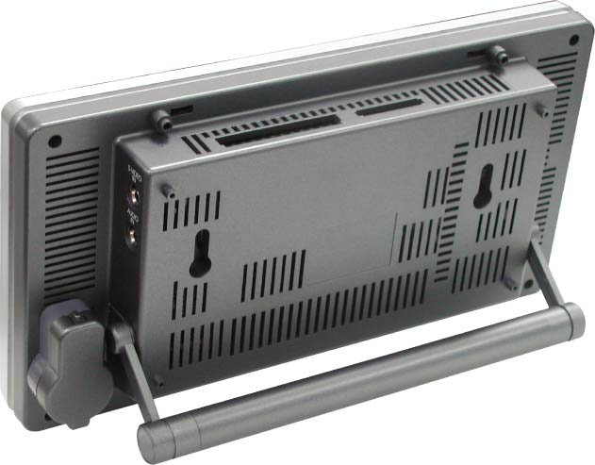
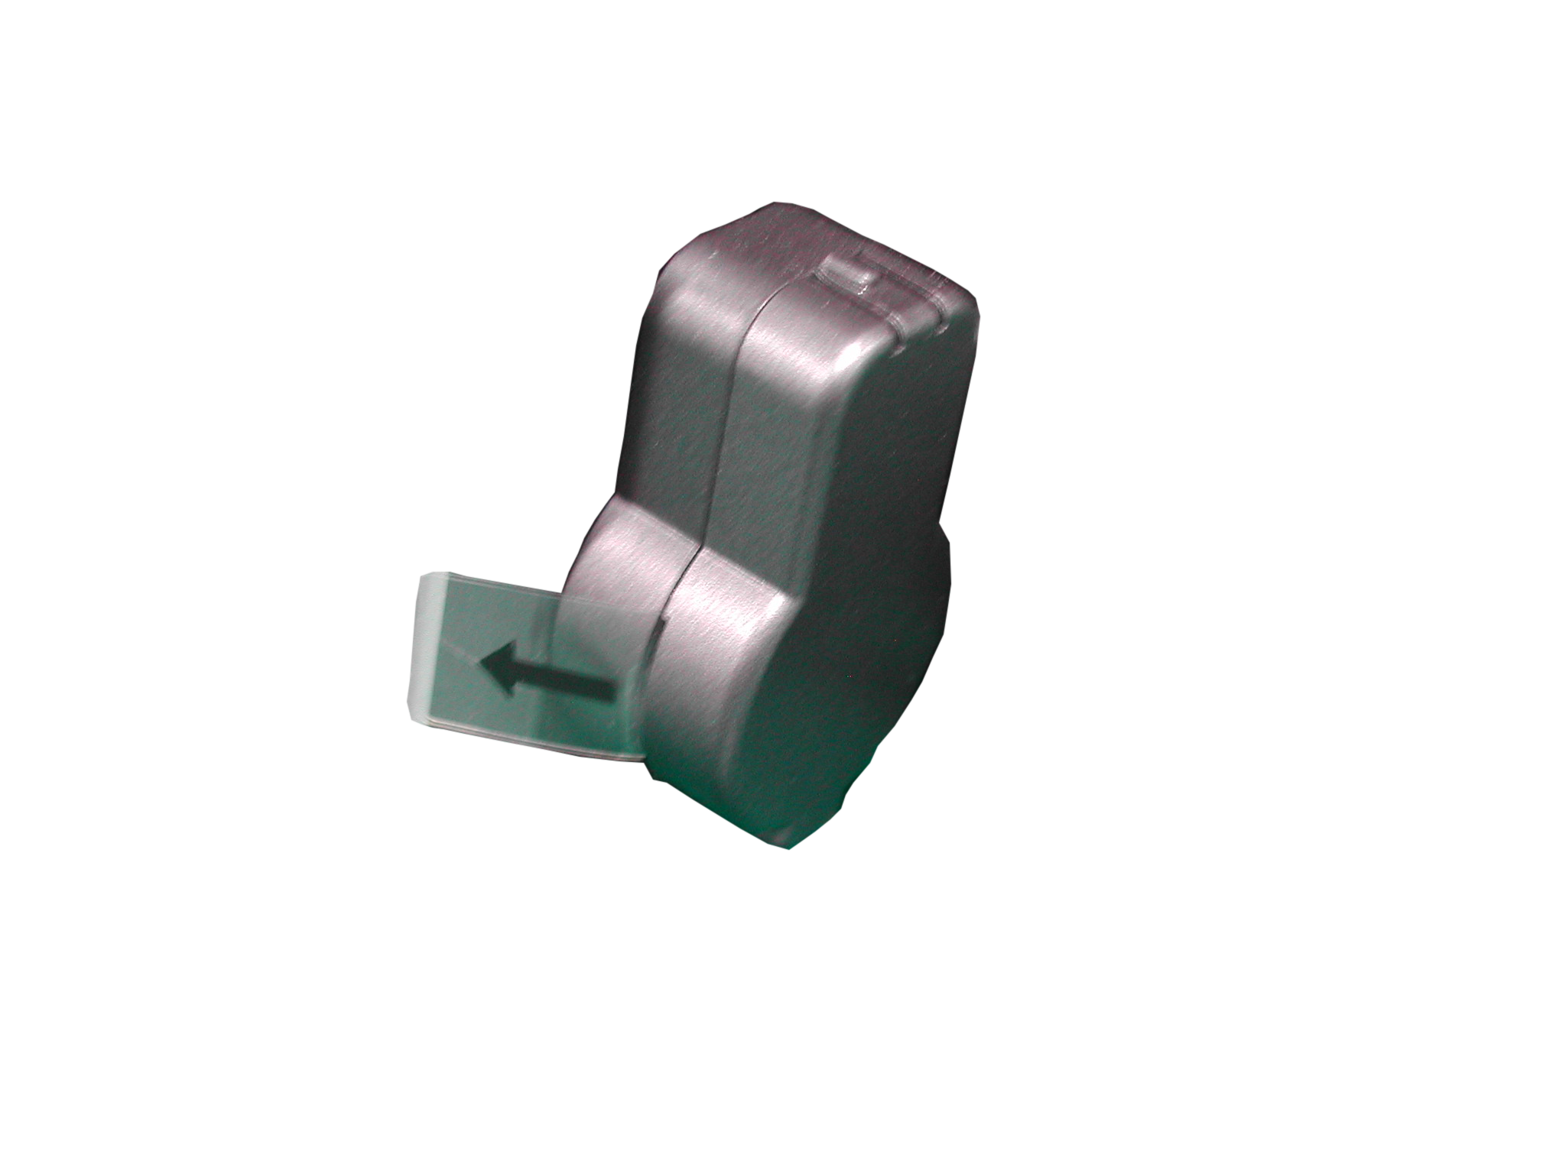
Battery for timer

- Press the EDIT key of remote control to open the timer setup window.
- Timer Setup Window
  - Use the Left key and Right key of remote control to select each item.
  - Use the Up key and Down key of remote control to change the value of each item.
  - Press EDIT key of remote control to save the change and exit the timer setup window.
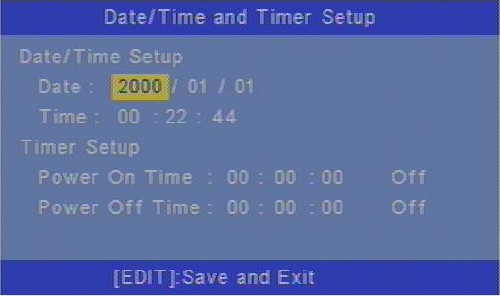

4.7 Photo Pan Function
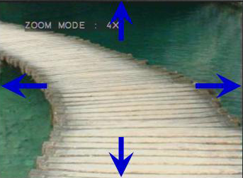
Photo can be moved while zoom function mode.

4.8 Photo Rotation
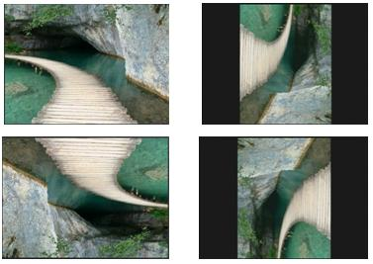

Photo can be rotated 90 degrees in one time.

5. Schedule Software Operation Reference
5.1 Install The Schedule Software
Please execute the “setup.exe” to install the Schedule software in the CD driver, please finish the installation procedure in accordance with the illustration below.

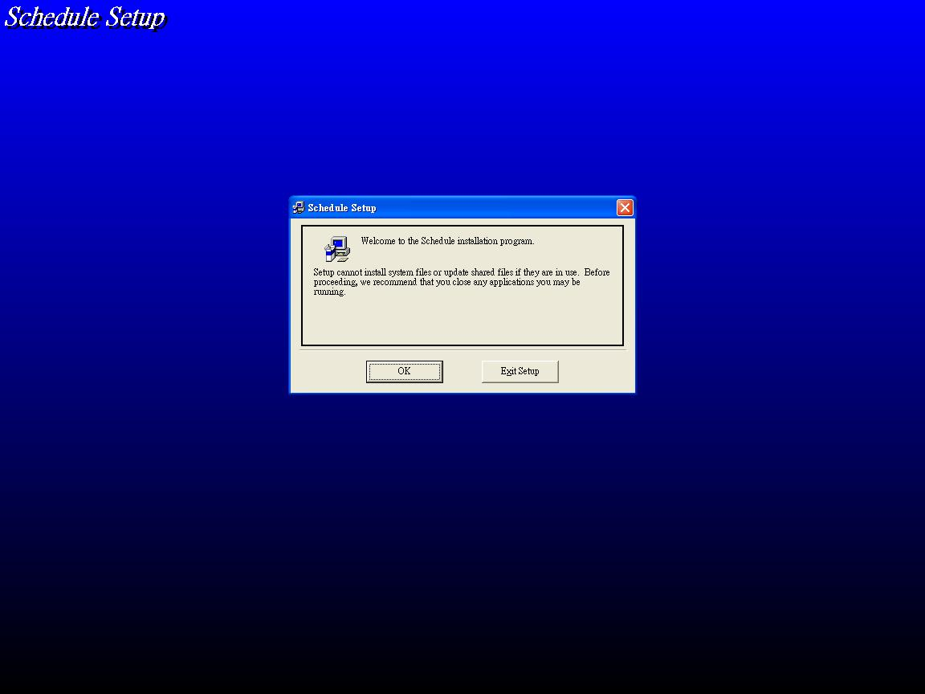
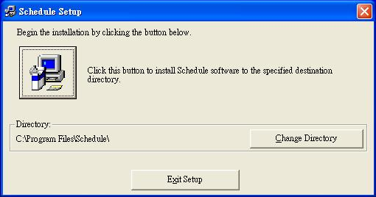
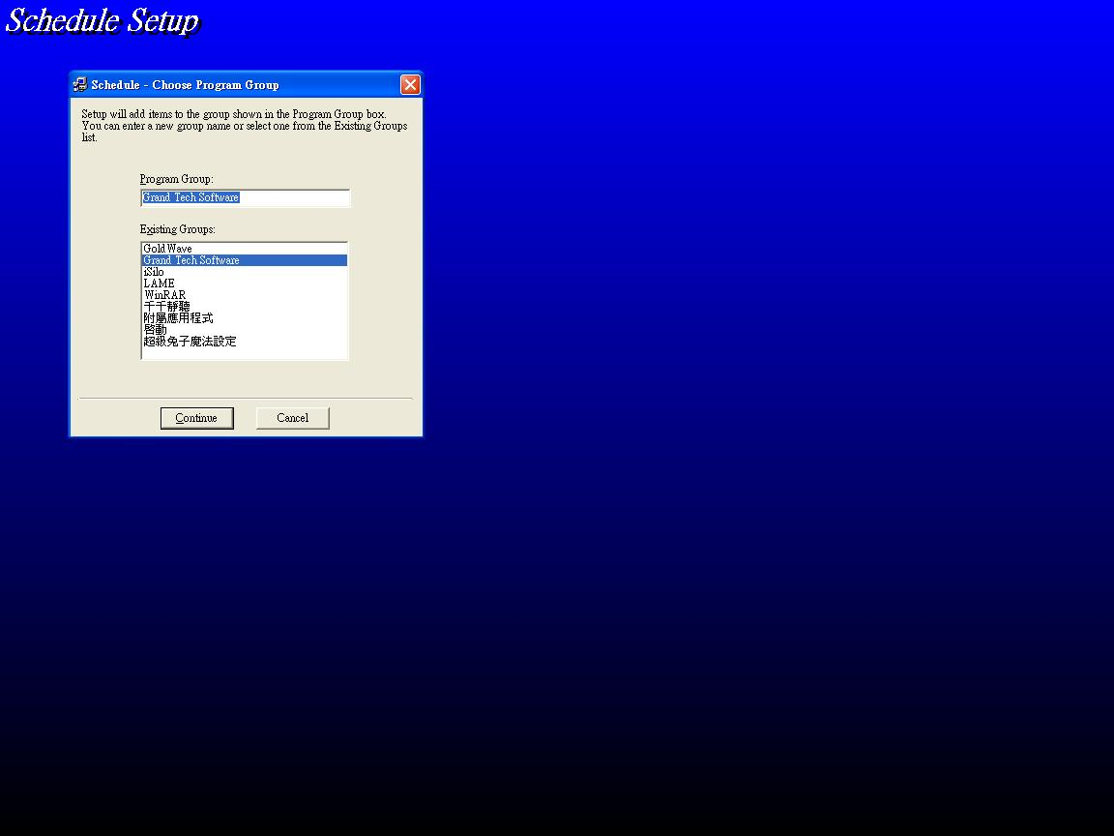
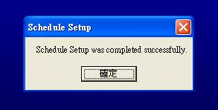

5.2 Setup The Schedule Software
- Please execute the software “Schedule Generator” to open the “Grand Schedule Generator” window on your PC, and the following diagram will appear.
- There are “Basic Schedule” and “Advance Schedule” two parts in the window.
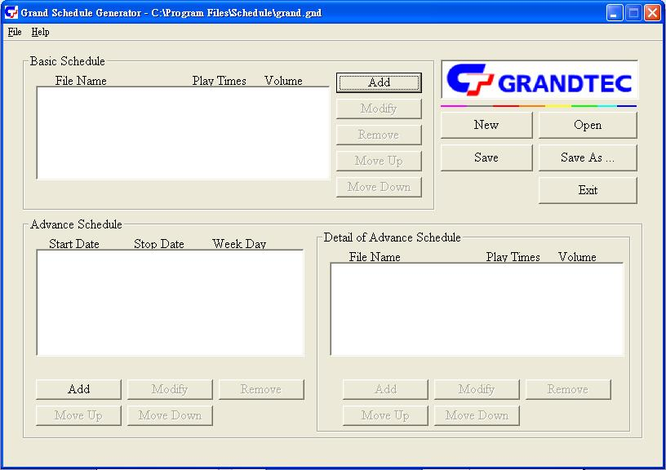

5.2.1 Basic Schedule
In “Basic Schedule” mode, you can select files that you want to play, and can also set up the volume and the play times of each file.
- Add：Click this button to add file that you want to play, and the following diagram will appear.
- Please click the “Browser” button to select a file that you want to play. You can also set up the “Play Times” and “Volume” of the file in the window. Click the “OK” button to complete the setup.
- You can click the “Add” button again to add other file.
- COPY Function：After selecting the file, please click the “Copy to…” button to copy the file to memory card.
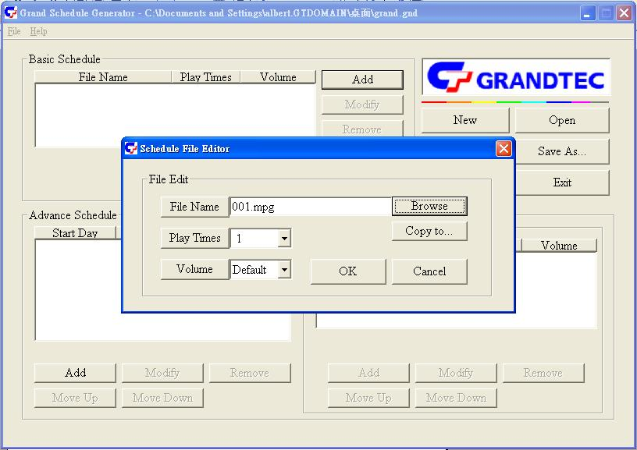

- Modify：Click this button to modify the file in the list.
- Please select the file that you want to modify in the list, then press the “Modify” button to modify.

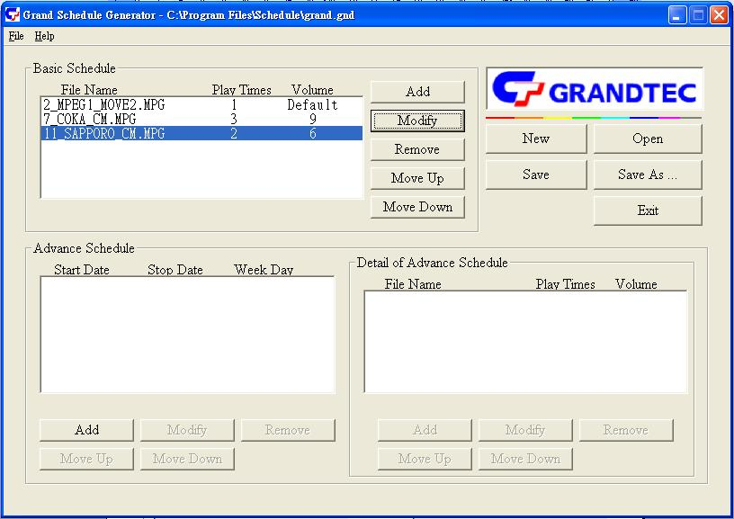
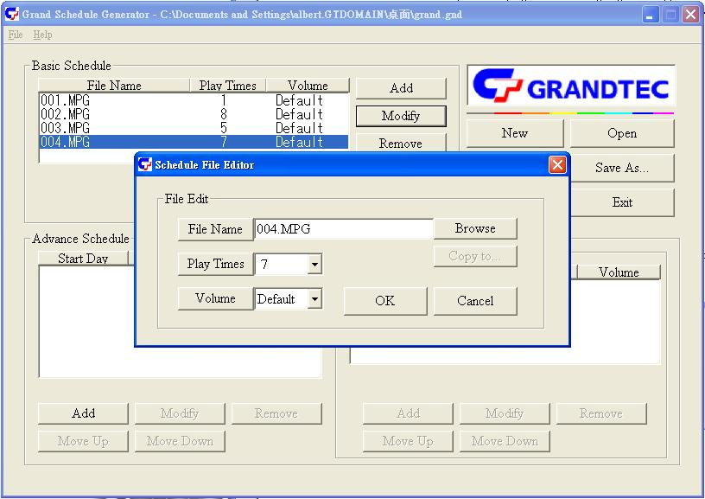

- Remove：Click this button to remove the file in the list.
- Please select the file that you want to remove in the list, then press the “Remove” button to delete.
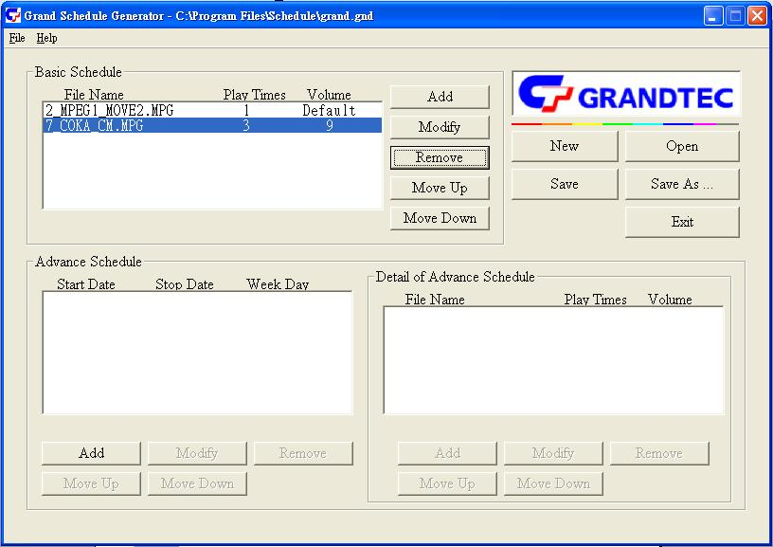
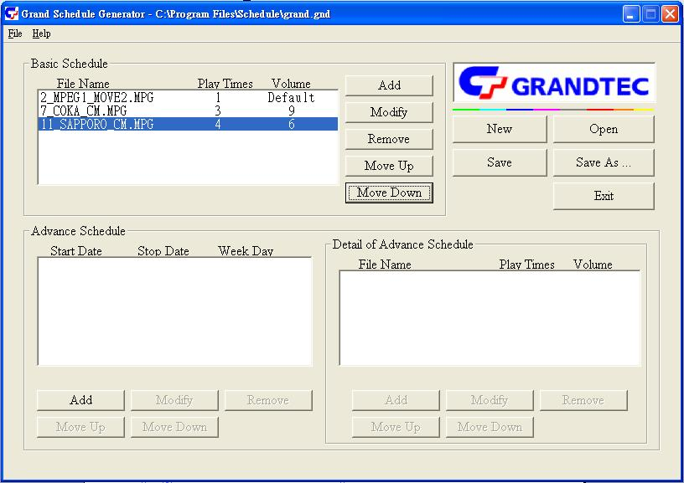

- Move Up / Move Down：Click these buttons to change the successively order that the file plays.
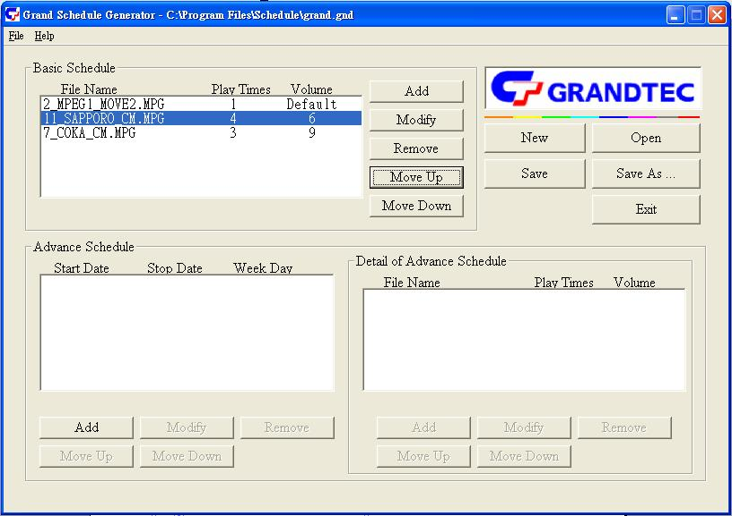

- After finishing all setup, press the “SAVE” button above right of the window, and a pop-up window displays to select the save path, then click the “SAVE” button to save.

NOTE：Please don’t rename the file (grand.gnd), otherwise the Grand 7” Vision Talk is unable to read.
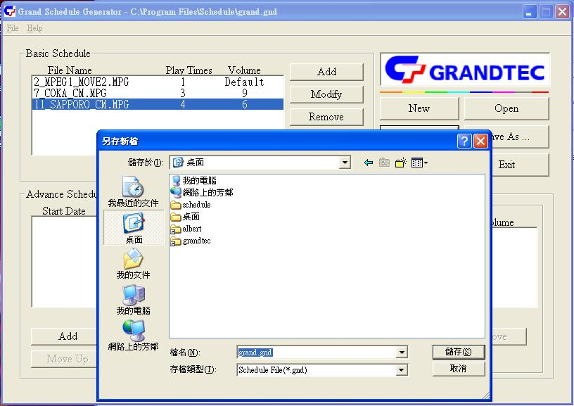

5.2.2 Advance Schedule
In “Advance Schedule” mode, you can select files that you want to play, and can also set up the volume, the play times, and the initial and end time to play of each file. There are “Time Setup “ and “File Setup” in the “Advance Schedule”.

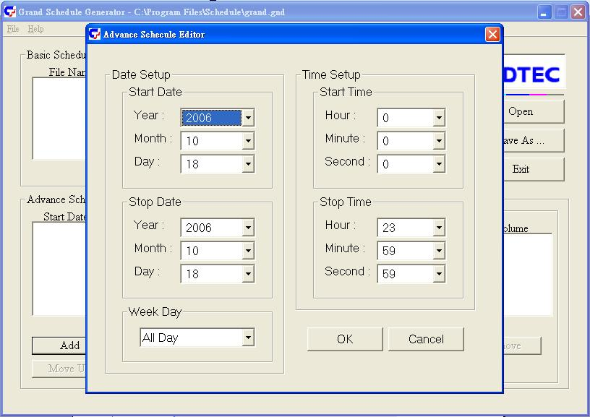
Step 1：Click the “Add” button in the part of “Time Setup” to open the “Advance Schedule Editor” window. Please set up the Start and Stop Date, Start and Stop Time and the Week Day, then click the “OK” to quit the window.

Step 2：Click the “Add” button in the part of “File Setup” to open the “Schedule File Editor” window. Please click the “Browser” button to select a file that you want to play. You can also set up the “Play Times” and “Volume” of the file in the window. Click the “OK” button to complete the setup. You can also click the “Add” button again to add other files.
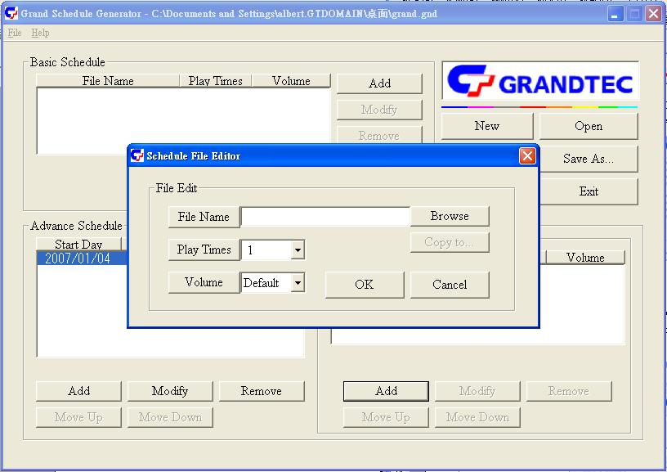

Step 3：Please repeat step 1〜2 to add the files wanted to play in other time.
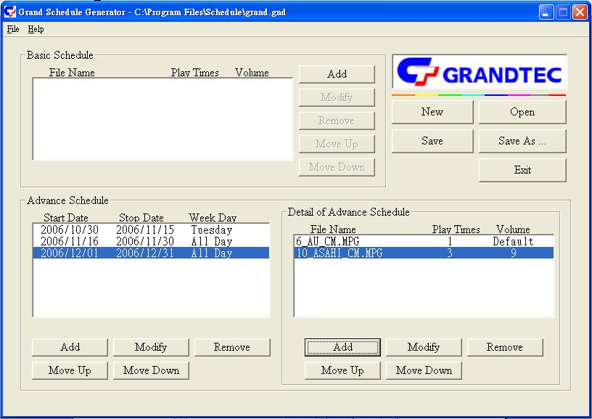

Step 4：After finishing all setup, press the “SAVE” button above right of the window, and a pop-up window displays to select the save path, then click the “SAVE” button to save.

NOTE：Please don’t rename the file (grand.gnd), otherwise the Grand 7” Vision Talk is unable to read.
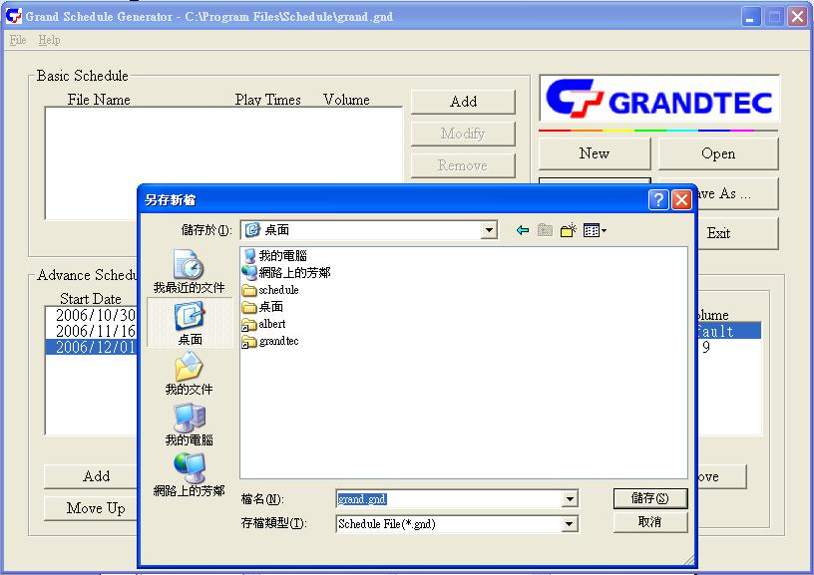

5.2.3 Explanation Of The Warning Message
- No any schedule！Can’t Save！
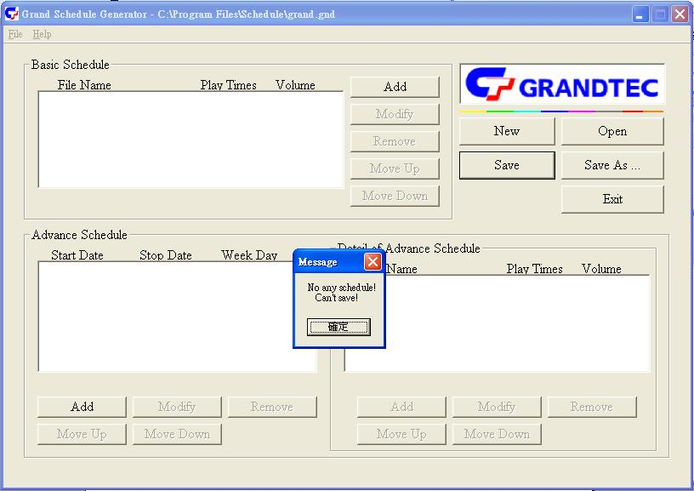
There is no schedule file in the “Basic Schedule” or “Advance Schedule” can be saved. Please add and edit a new schedule file first.

- Data Setup Error！
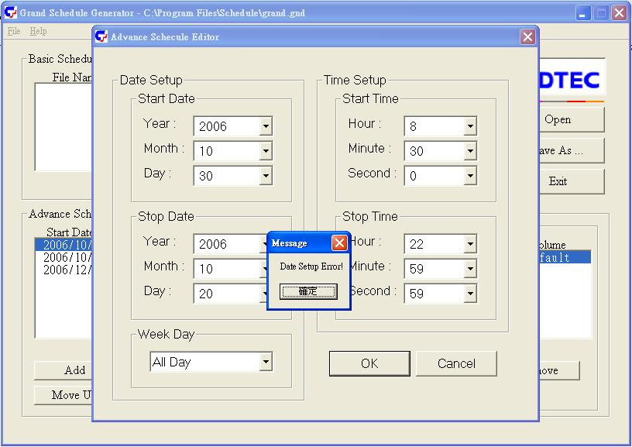
There are some mistakes in the “Advance Schedule”. Please check the date or time of schedule is wrong or conflict.

- No any schedule file in advance schedule 1！Can’t Save！
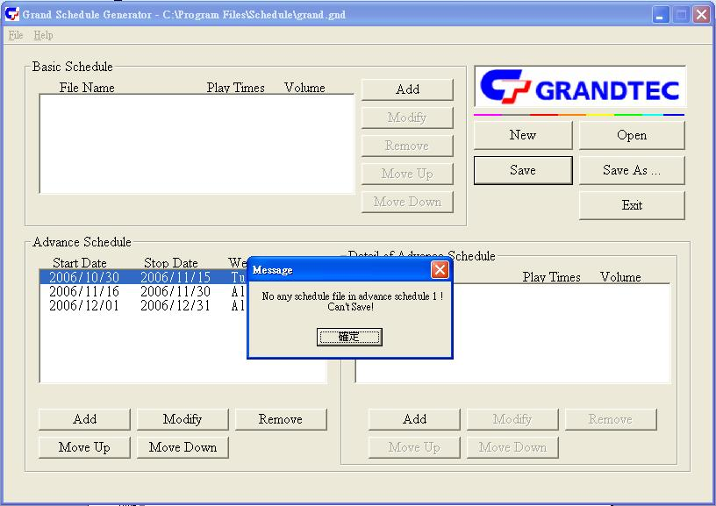
There is no schedule file in the advance schedule 1. Please add files that you want to play in the advance schedule 1.

5.3 Apply The Schedule
Please put the “grand.gnd” file and the associated files that you want play into the memory card, then insert the memory card to the Grand 7” Vision Talk. Then the Grand 7” Vision Talk will auto play the files at the designated time.

6. Trouble Shooting
Situation | Check Point
No Picture | 1. Check if the power supply is connected.  2. Make sure turn on Grand 7” Vision Talk.
No responding from  the remote control | 1. Please check if the power is in shortage for the  remote control.  2. Please check the bottom of the remote control.  3. Please check if there’s any barrier between the  remote control and product.
Memory card | 1. Push cards gently and securely.  2. If the card does not insert easily, check the direction.  3. Confirm format of the card.  Grand 7” Vision Talk supports CF Type I/II, IBM Micro  drive ( MD ), MMC, SD, Memory Stick and MemoryStick PRO.
No sound | 1. Please check if the mute function is on.  2. Please check if the volume is proper.
Timer does not permit | 1. Press “ EDIT ” key to open the timer setup window, confirm  whether time is correct.  2. If has the use “ Timer Function ”, suggested confirm whether  time is correct every three months.
When you need RMA or advanced technique service, please fill this form as detail as
possible and FAX to your dealer.

Product S/N:
Name:
TEL No.: | FAX No.:
E-mail address:
Full Address:
Problem description:

