GRAND EYEZ TO GO
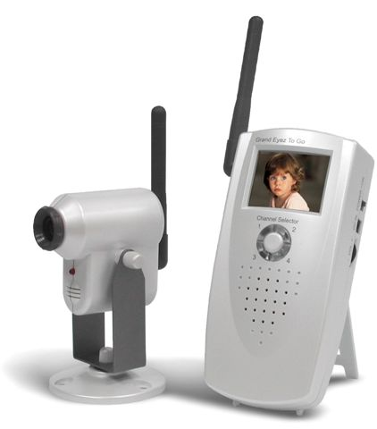

Grand Eyez To Go is Portable Security system for your home/office area. It includes CMOS Camera and microphone integrated into 2.4GHz wireless transmitter and 1.8" TFT Panel with 2.4GHz wireless Receiver. The Picture and Audio capture from CMOS camera and display in 1.8" TFT Panel with real time. Built in battery packs, So it will be portable moving in your desired area. Built in Speaker, So you can listen the audio sound Simultaneously with picture display. Grand Eyez To Go can also acts as anti-Detection for your environment for 2.4GHz reveal Camera in Public square. CMOS transmits images and audio up to 100 meters in open areas (30 meters through walls, etc.). It is ideal for home security, including child and room monitoring. Transmitter Cmos Camera can use up to 4 pcs with different RF frequency channel and Receiver can accept these signals by changing channel selector.

Features:
●Ideal for home security, including child and room monitoring.
●NO cable need with Grand Eyez To Go system.
●Built in 2.4GHz wireless transmitter and receiver.
●Transmitter include Cmos Camera and microphone for picture & audio monitoring.
●Receiver include 1.8" TFT LCD Panel & speaker to display the Video and listen the audio.
●Wireless AV transfer range up to 30Meter for indoor and 100Meter for outdoor.
●Dipole antenna provides optimal video and audio reception.
●Four channels available for best quality selection.
●Anti-Detection for your environment for 2.4GHz reveal Camera in Public square.
●Built in battery packs for portable use.
●Supports NTSC or PAL video systems
●LED for channel indicators
●Designed to minimize external interference

SPECIFICATION:
Transmitter:
- The stand of the transmitter can be mounted on the wall or ceiling.
- CMOS camera main body : A revolving kind at 360 degree.
- Antenna: A revolving kind at 270 degree.
- Built-in microphone.
- The world smallest CMOS built-in 2.4GHz Wireless Color Transmitter.
- With the channel LED indicator.

Receiver:
- Channel selector with LED indicator.
- With the 2.4Ghz Wireless video & audio.
- Video display with 1.8” TFT LCD panel.
- Built in Battery Pack for portable use.
- NTSC/PAL Auto selection.
- Free from the anxiety about the interference caused by the landform or skyscraper.

1.6 Package Contents
- Grand EYEZ TO GO CAMERA (Transmitter)
- Power Adaptor * 1 ( 6V/600mA ~ 6V/800mA )
- Grand EYEZ TO GO LCD PANEL (Receiver)
- Power Adaptor * 1 ( 5V/600mA ~ 5V/800mA )
- User’s Manual.

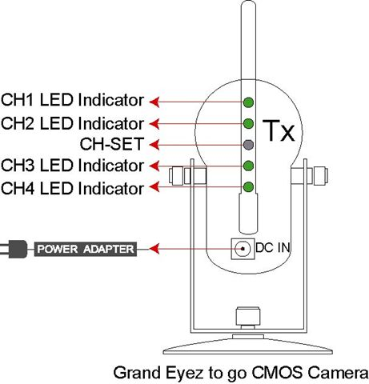 | 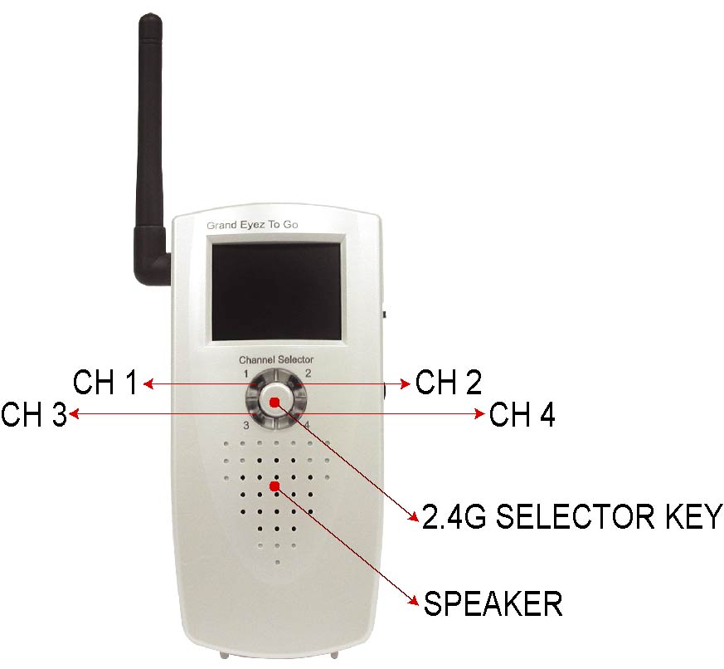

CHAPTER 2

Hardware Installation
2.1 Camera Installation and setting up the channels
- Grand Eyez To Go system is no cable need. So, It is very easy to assembly/set up.
- Grand Eyez To Go TX ( Cmos Camera ) can fixed in anywhere of you indoor area. It can be mounted in any degree of ceiling. Camera sensor and 2.4Ghz wireless transmitter Antenna can adjust for directions.
- Grand Eyez To Go Tx (Wireless Transmitter): plug-in the adapter (DC 6V ) and set up the channel (4 selectable channels).
- For more Camera, Please mention for channel setting between these camera otherwise Video camera will be Interferenced each other.
- Micro Phone is assembly in Camera sensor units. It is very good for audio transmitting.
- The Last channel can be saved after you turn off the power.
- (Add channel 5~8): Connect power first then press ”CH-SET” button about 15 second
- (Delete channel 5~8): Power off then press ”CH-SET” button and turn on the power.

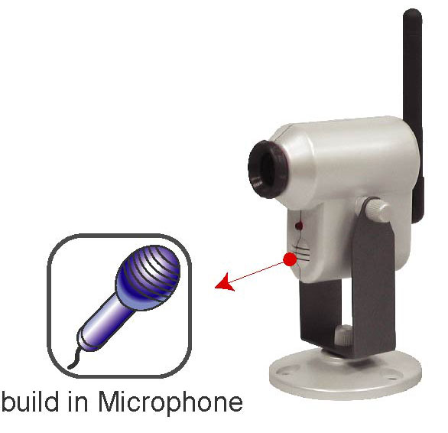

LED indicator for Channel display ( For additional Channels 5 ~8 Setting )
CH1 | CH2 | CH3 | CH4 | CH5 | CH6 | CH7 | CH8
● | ◎ | ◎ | ◎ | ◎ | ● | ● | ●
◎ | ● | ◎ | ◎ | ● | ◎ | ● | ●
◎ | ◎ | ● | ◎ | ● | ● | ◎ | ●
◎ | ◎ | ◎ | ● | ● | ● | ● | ◎
PS.●LED light ◎LED no light

Specification of Cmos Camera Transmitter
Type Standard | NTSC/PAL
Pick Up Elements | 1/3” CMOS Sensor
Frequency 4CH slide  Switch  PLL Control | CH1=2410MHz  CH2=2430MHz  CH3=2450MHz  CH4=2470MHz
Frequency Deviation | +/-100KHz(10℃~50℃)
RF Output Power | Vcc=3.3V, LOAD=50Ω,10 dBm
Antenna | DIPOLE(85mm)
Horizontal scanning  Frequency | NTSC 15.734KHz
Horizontal scanning  Frequency | PAL 15.625KHz
Vertical scanning  frequency | NTSC 59.94Hz
Vertical scanning  frequency | PAL 50.00Hz
Resolution | Horizontal 300 Lines
Resolution | Vertical line 300 Lines
S/N ratio | With AGC OFF 46dB
Minimum Illumination | 3 Lux (at F1.2)
Built in | Condenser MIC
Power Source | 6V DC 800mA
Operating Temperature | 10℃ ~ 50℃
Operating Humidity | 5% ~ 85%
Dimensions | (L)70mm*(W)58mm*(H)92mm, Anttenna:85mm
Weight | 95g

2.2 1.8” TFT LCD Panel display Installation and setting up the channels
- Grand Eyez To Go RX is Plug and Play. No need to use any cable.
- Grand Eyez To Go Rx (Wireless Receiver): supports for DC 5V Power adaptor OR Battery AA * 3pcs.
- By using Battery AA * 3pcs, it can be moved to any where of your desired area.
- If DC Adaptor and Battery both are connected, Power is take from DC adaptor.
- Using Rechargeable Battery or High capacity Battery, using time can up to 2 Hours.
- Set up the channel , then Receive the Video picture and Audio from transmitter side.
- Grand Eyez To Go has Audio speaker and Volume control to adjust the Audio out.
- The Last channel can be saved after you turn off the power.
- (Add channel 5~8): Connect power first then press ”CH-SET” button about 15 second
- (Delete channel 5~8): Power off then press ”CH-SET” button and turn on the power.
- (Auto sequence) Turn on the power and press ”CH-SET” button about 5 seconds Press ”CH-SET” button again to disable auto sequence.
- The users can use four wireless Transmitters on 4 different channels. The Wireless Receiver can receive up to 4 difference frequency signals and display the 4 pictures in sequence.
 | 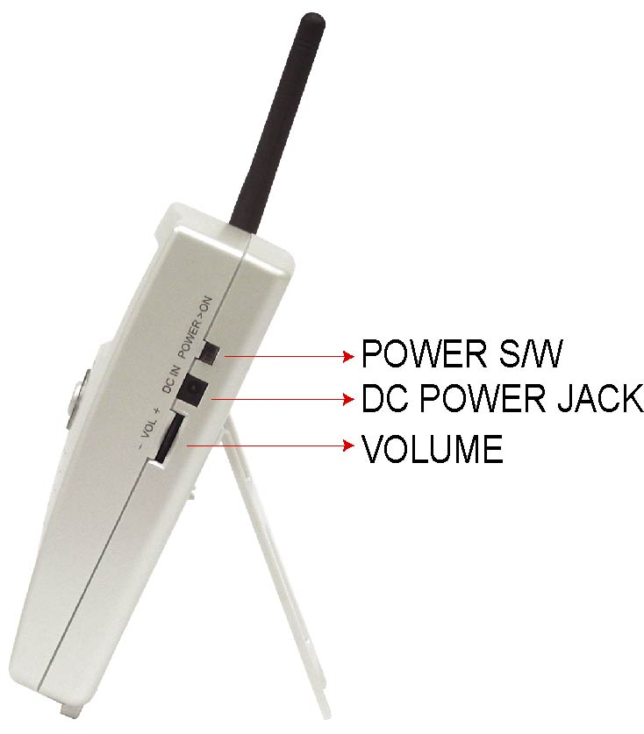
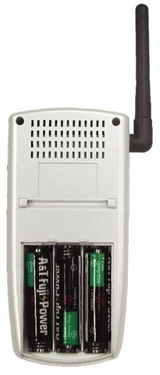 | 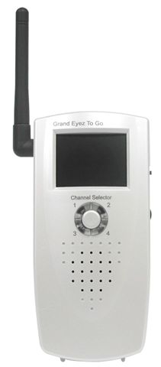
NOTE:
1 receiver can accept signals for 4 different channels. Please set the receiver’s switch to Auto function and the receiver can receives the signals from Channel 1~4 with sequence and cycling.
CHAPTER 3
3..1 Grand Eyez To Go Quick application note.
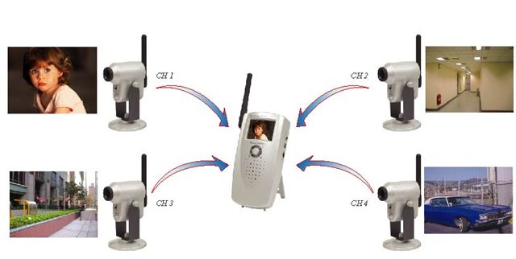

Grand Eyez To Go Cmos Wireless Transmitter:
- Grand Cmos Camera must be fixed where your want to secure.
- Power adaptor plug to Cmos Camera.
- Grand Cmos Camera can use up to 4 pcs for different area.
- For four different Camera, Wireless RF channel must be different to each other.

Grand Eyez To Go 1.8” TFT LCD Display Receiver:
- Grand 1.8” TFT LCD Display receiver can use for Power adaptor and Batteries.
If plug Both items, Power is taken from DC power Jack.
- For Portable use, Batteries need AA * 3 pcs. Battries must be high duty capacity.
Battery can be used up to 2 hours.
- There is volume control of Audio adjustment for Speaker.
- Power On/Off switch, If you do not want to use, Please switch off the power for Battery charges capacity.
- There is channel selector for RF frequency channel that you want to receive.

3.2 :Precaution :
Grand Eyez To Go CMOS Transmitter broadcast their high-quality Audio and Video signal using dipole type antenna as show below. For the reason to get optimal performance, try to minimize the number of obstacles ( e.g. your TV or other electronics, large furniture) between the transmitter and receiver units.
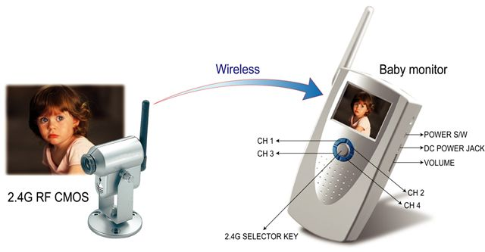

CHAPTER 4
Trouble Shooting
Please check the following chart for a possible solution of problem. If you are experiencing, a minor adjustment may eliminate the problem.

Symptoms | Possible Solutions
No picture or sound | - Be sure power adapter is plugged in.  - Be sure for Batteries have charges.
Interference Noisy picture or audio | - Adjust receiver antenna orientation.  - Adjust transmitter antenna orientation.  - Select a different channel with the CH-SET on transmitter and adjust the CH-SET switch of Receiver to match up the channel.
Channel can not fixed  (manual mode) | 1. Set the Manual/Auto switch to  “manual”.

When you need RMA or advanced technical service, please fill in this form as detailed as possible and FAX to your dealer or service representative.
Product S/N:
Product Name:
TEL No.: |  | FAX No.:
E-mail address:
Full Address:
Hardware condition:
Mainboard chipset:
Mainboard CPU: |  | CPU clock: MHz
Main memory: MB |  | Cache memory: KB
VGA card: |  | Display memory: MB
Sound card: |  | Hard Disk: MB
Other add-on cards:
Monitor: | Horizontal Freq.: KHz to KHz  Vertical Freq.: Hz to Hz
Problem description:

